DBMS Practical No.: 12

**Name: yash ajay magar**

**Experiment No 12: Execute queries using Arithmetic functions**

Exercise:

1. Calculate cube of following numbers: 12,14,16 2.
2. Display details of salary of employees with roundup value.

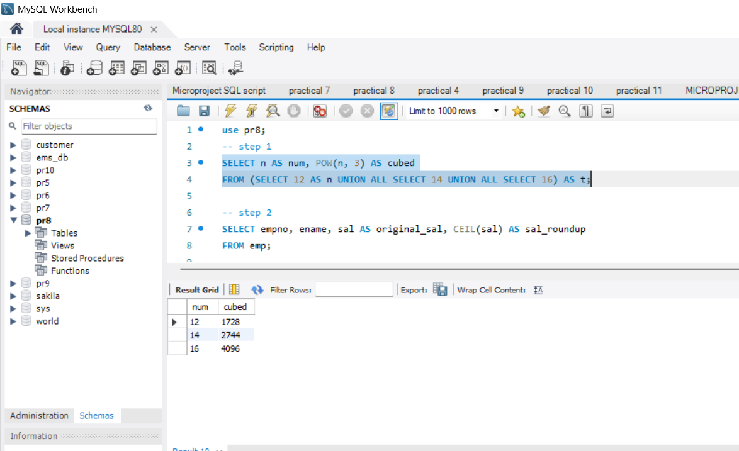

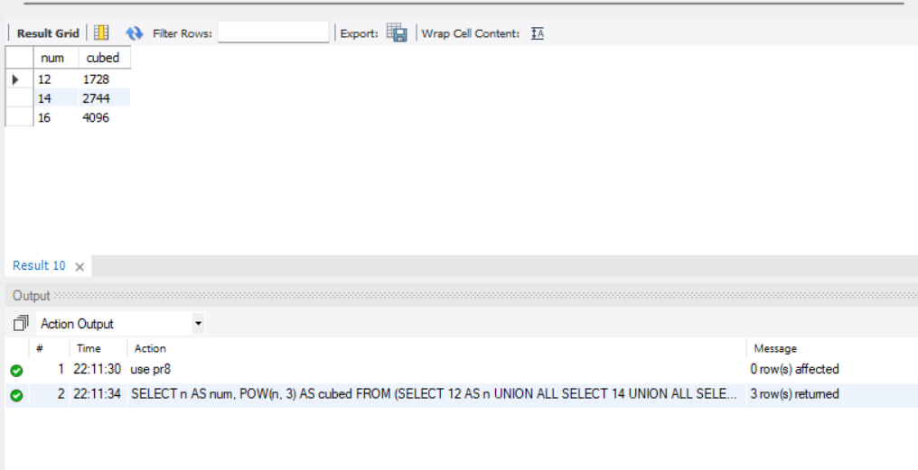

Display details of salary of employees with roundup value.

